After Point 1 :
Client Comment:
We are using a mixture of Google and Typekit Fonts - are we going to have an issue with this on the live server? How do these fonts work - does someone pay for them or do you guys have some sort of developer's license? Our last developer had a Typekit license so we didn't have to pay. We do not want to pay for any fonts

MD Comment:
No, We do not have any license for the Typekit font, That's why earlier we asked you for the fonts and you provided. So we used it in the website.

HiC Answer: We need to change the body copy font and would like to use “Merriweather”
https://fonts.google.com/specimen/Merriweather 17.5 font size, leading 31, Tracking 50.

Point 7:
Client Comment:
7. Please Fix spacing on the hero. The white text blocks are too far apart Reference “Post Page
1” psd for spacing.

MD Comment:
We are little confused here, By "too far" you are referring the space from top to bottom? Please guide us here.

HiC Answer: Reference the image below to see the spacing I’m referring too. Check “Post Page 1 psd” For spacing and font size.

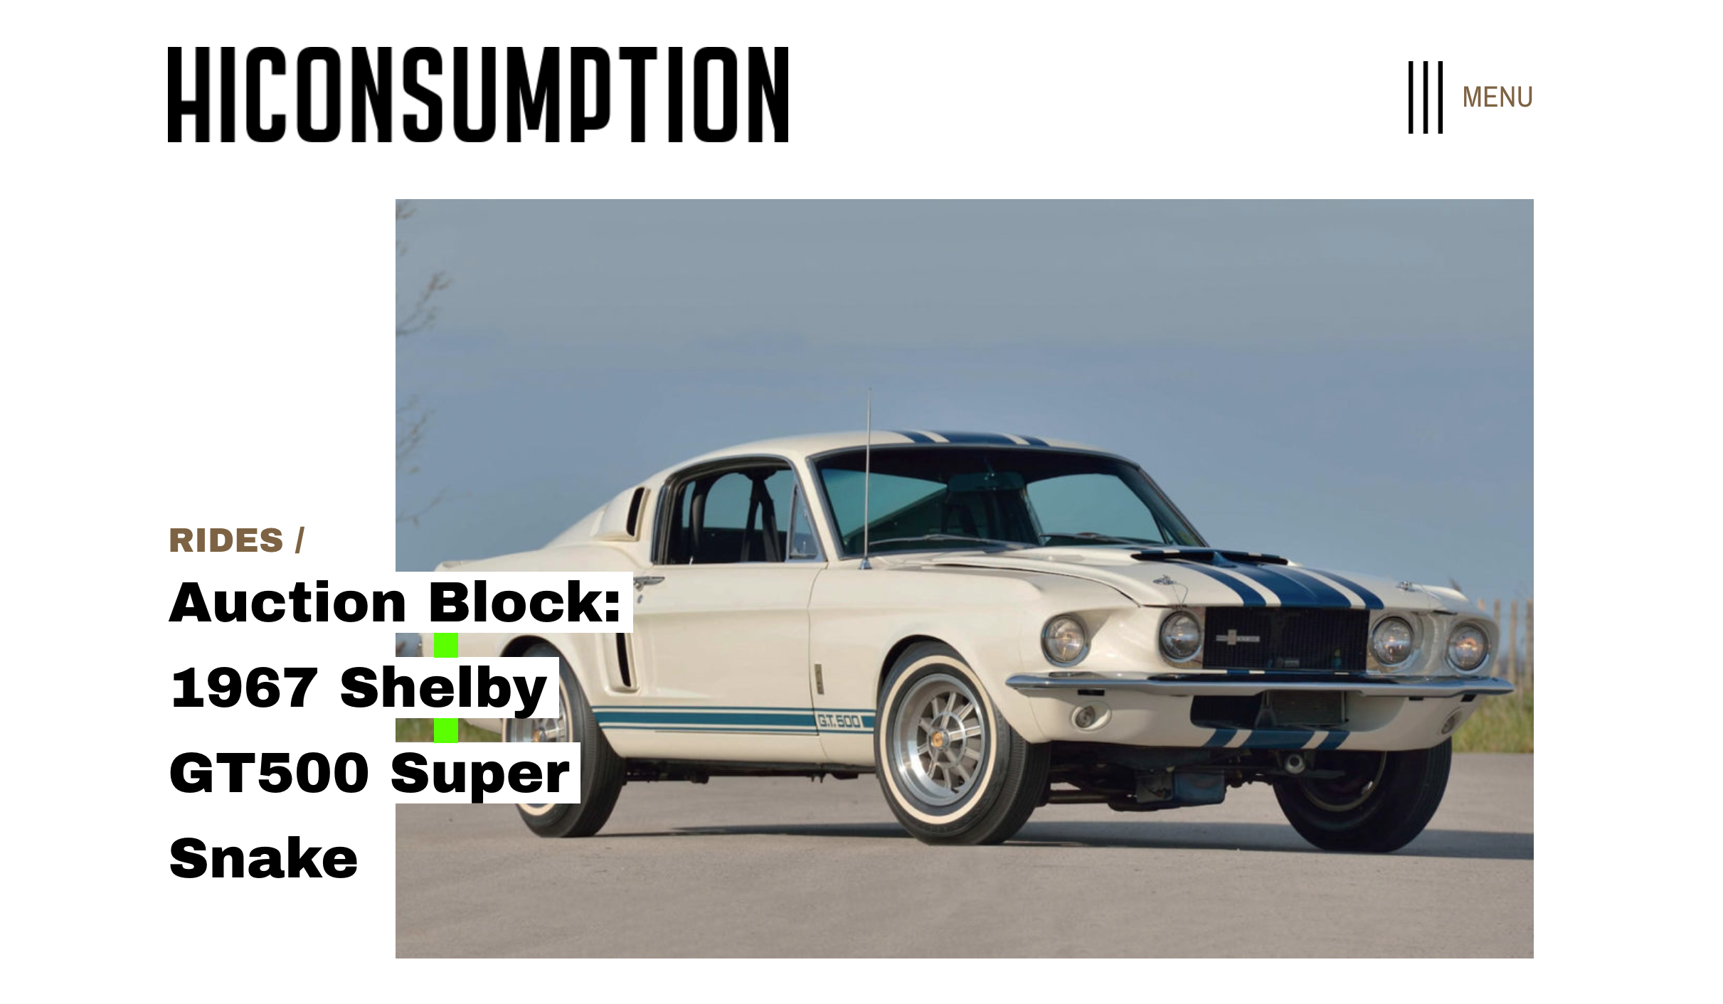

Point 13:
Client Comment:
13. From the Shop: Fix the grey outline around the product container box. Please Make the
container box white.

MD Comment:
The grey outline we will. remove. Can you please explain more what you mean to say by "Please make the container box white"

HiC Answer: Just remove the “grey line”. Never mind the white container.

Point 22:
Client Comment:
Test Styling: Please take the bold effect off body copy only. The styling looks good on the block and pull quotes. Please reference Test Styling Psd for styling and spacing.
MD Comment:
We are using the exact same style as per the PSD but the fonts on browser render little different.

Point 22. Please use https://fonts.google.com/specimen/Merriweather . Reference question 1.

Point 24:
Client Comment:
24. Short Coeds: Anecdotes Container needs to be updated. Dev site is showing old styling.
Please reference short codes psd For styling.

MD Comment:
We are using the existing shortcode to develop this similar block. With this shortcode, new styling is not possible and we can't change it because for this change we need to go through all the posts content and make changes accordingly.

HiC Answer: Ok, I didn't realize we were using old short codes. I’m going to redesign within our parameters to match the site better.

Point 27:
Client Comment:
Partner tags: The Category Page is showing two Partner tags and the homepage is showing one. The category Page should follow suit of the home page. There should only be one partner tag on the Category Page.

MD Comment:
Please check attached image HiConsumption 1024 Archive Page.jpg.
There are two partner tags.
Still, please let us know if we need some modifications here.
If we need only one partner tag post here, then what should be beside it?
If we are planing to show only one partner post (and we are having total two posts) so which one should be added and which one should be left out?

HiC Answer: This is how Sponsor content works. Reference example below “Rides” Category . You will notice the top containers are from categories “Gear” and “Style”, but are living in the “Rides” Category. This is where sponsored content lives. Meaning both of these containers will have a partner tag attached to the bottom right. These two containers will live in same place on every category throughout the site even the homepage. Once the sponsored content/Partner tag expires, The two containers will host whatever the latest story is from that category.

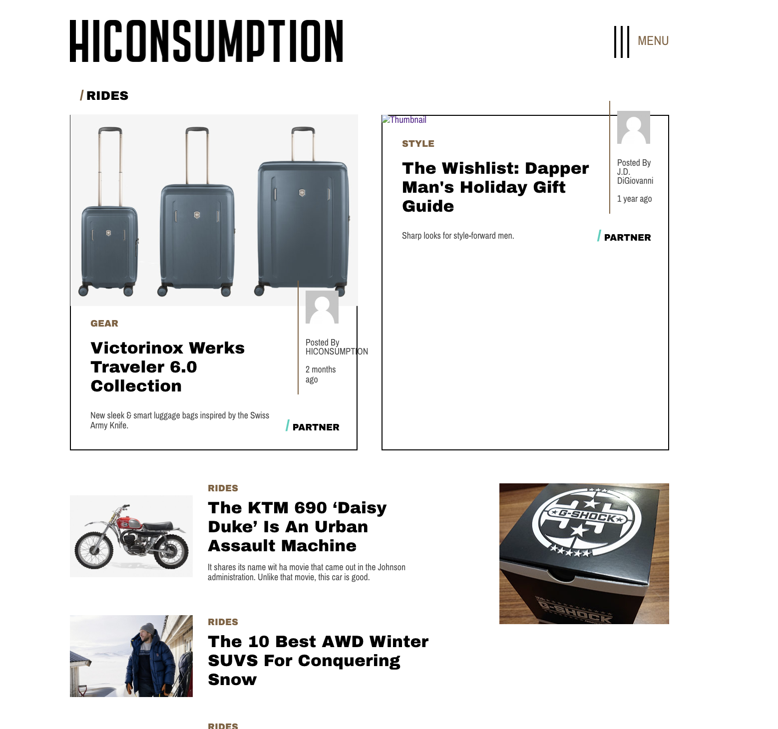

Point 28:
Client Comment:
Short Codes: Looks like we are pulling new and old shorts codes. Please update all new short
codes

MD Comment:
It is added in the numbered format from the editor, it is in old website also: https://dev.hiconsumption.com/2018/10/best-wood-for-a-campfire

HiC Answer: Ok, I didn't realize we were using old short codes. I may have to redesign.

Point 29:
Client Comment:
Buyer’s guides: The “Buyer’s Guide” link, does not seem to be pulling any content related to the subject.

MD Comment:
We have added partner posts, can you please confirm here?

HiC Answer: Yes, there should be Partner posts on the “buyer’s guides link”. This will only happen when the containers are selected in the back office to be sponsor/Partner content. I believe this is taking place in the boost Tab.

Point 33:
Client Comment:
Change hover over effect on “category titles” from sea foam to black.

MD Comment:
“category titles” are appearing in many section/pages. Can you please let us know where specifically we need to change this

Additional Revisions After Testing Live Posts:

Additional Revisions After Testing Live Posts:

Helpful Tips:

There seems to be a misunderstanding as to how the site actually operates, and it’s creating a ton of issues on our end for testing.

[capped_content] is a shortcode that we use to fire off the current ATF (above the fold) 300x250 ad. Everything within that shortcode is wrapped around that ad

Example: [capped_content] All of this content here would wrap around the ad. The codes outside of this are what cause the ad to fire. Without them, there is no ad that fires. It also creates a 900px margin - though that’s not important for the new site. [/capped_content]

[capped_content_660] is a shortcode that we use to create a 660px margin. It doesn’t have anything to do with ads. It simply allows us to create a silo effect on the copy/images.

Any body copy that is not within the confines of either of those shortcodes expands to the full width of the site margin (which is 1087px on current site)

For the new site:

We need all of this old content (15k+ posts to remain looking good on the new design), so keeping that stuff in tact is important. But we also need to make sure that you guys develop rules similar to these for the new content adhering to the new site design - which includes (but is not limited) new site margins, new image sizes, new ad layout/sizes/ad server, etc.

Example: We will no longer be using 660px margins for the silo effect, so we need you guys to develop a 680px capped content code to adhere to the new content.

We created Draft post called “DEV TEST POST” on the live site. It’s essentially an older post copy/pasted. Please play with this to understand how all of this works.

Testing Old Content:

We need to make sure all of our old content still looks good. I’ve placed a post below from 2012 that uses a 630px image for the Hero. We used that style for a while (varying heights).

-You will also see that it fires off a 300x250 ad centered (different than the rest of the site) as we updated the way we fired ads, but still needed a way for the 300x250 ad to show on the old posts.
https://hiconsumption.com/2012/09/lego-architecture-fallingwater-residence-by-frank-lloyd-wright/

http://hiconsumption.dev1.in/2012/09/lego-architecture-fallingwater-residence-by-frank-lloyd-wright/

Then we updated the site again to having 2 options for post types: a 960px Hero or 630px Hero when a 960px image was unavailable.

960px Hero example: https://hiconsumption.com/2014/04/bentley-hybrid-concept/

http://hiconsumption.dev1.in/2014/04/bentley-hybrid-concept/

630px Hero example found on this page (everything else around it is 960px Hero): https://hiconsumption.com/page/1225/

630px Hero post: https://hiconsumption.com/2014/03/1950s-boat-house-cabin-in-washington/

http://hiconsumption.dev1.in/2014/03/1950s-boat-house-cabin-in-washington/

We can’t figure out how you guys are choosing which old post become which new post styles. For instance you have a buyer’s guide that utilizes the Style 2 Grid (1200px) below:

http://hiconsumption.dev1.in/2018/11/best-military-vehicles-you-can-own/

But then you have other posts using the exact same format on our old site using the post Style 1 (1000px) on the new site?

http://hiconsumption.dev1.in/2018/11/best-knife-fighting-styles/

Solution:

We think the best solution is to convert all of the content that’s currently site to the post Style 1 (1000px) for the new site design. This will let you clean some stuff up in the “HiConsumption Post Formatting Options” section.

-Delete both the old Post Styles from the dropdown (remove clutter) - this includes both Default (630px) and Small (660px)

-Remove the “Legacy Formatting” as that was to allow us to carry over old content styling into a newer site design years back. But seeing that we are just converting everything to 1 style, that should take care of that as well.

-Remove the “Post Subtitle” option as we aren’t using that on the new site design.

*Keep in mind, we need the option to switch over these old posts manually from the post Style 1 (1000px) to the post Style 2 Grid (1200px) if need be. We will do that on our end once the site is live for some specific content (How-To, Guides, anything with a silo effect)

1. Client Comment:
Client Comment:

After point 3:
There should be 2 other 300x250 ads firing in the copy of this post type. The first one should be automatically be inserted after the first image > first copy break and then second automatically inserted after second image > first copy break. Reference Post Page Style 2 PSD for example.

MD Comment:
Please describe it.
Will the ads be inserted from editor by passing advert=true in capped content shortcode?

Post Style 2:
http://hiconsumption.dev1.in/2019/01/the-10-best-awd-winter-suvs-for-conquering-snow/

There should be 2 other 300x250 ads firing in the copy of this post type. The first one should automatically be inserted after the first image > first copy break and then second automatically inserted after second image > first copy break. Reference Post Page Style 2 PSD for example.

Ian Comments:

This is a good question, and we’re not 100% sure on the logic for how these ads should be inserted into the body copy. Manually seems easy (creating a custom shortcode where we can place it wherever we’d like), but then we have to rely on humans to enter it every time. Automatically would be cool because it’s set it and forget it, but how would we do that? High Snobiety is doing something very similar with their ads. Can you guys please take a look at this and let us know how they’re doing it ? https://www.highsnobiety.com/p/lil-pump-latino-identity-hip-hop/

We’d like to work with you guys to figure out the best solution here.

Client Comment:
4. Post Style 3:
http://hiconsumption.dev1.in/2019/01/tom-hardy-brings-the-riot-in-new-venom-trailer/
-Under HiConsumption Post Formatting Options, we need an option that says “Style 3 Video.” This way our writers can select that and still used the [capped_content] to fire off that in-body 300x250 ad.

MD Comment:
We are using old development flow, according to it, if there is video url then video post style will be applied.

Ian Comments:

-That makes sense, then we don’t need that Style 3 Video. What we do need is to change the current note on the “Video Settings” to read “Please note this will override any post style.”

-We also need to figure out how this 300x250 ad is firing. It seems to always fire, no matter what. The [capped_content] currently doesn’t do anything. The 300x250 ad is there even with the [capped_content] shortcode removed - which doesn’t make sense. Please see my previous logic in “Helpful Tips” above to start dialing this in.

Client Comment:
6. Features:
Any post tagged with “Features” currently shows up in the “Features” section (which is perfect), but that also removes it from the “Latest Stories” feed. Every post published should always show in the “Latest Stories” feed because that should be a running feed of all of the stories published on our site.

MD Comment:
This is how current development is, like it removes any post which is already in a section to avoid duplication of a post showing on same page
Do we need to show them in "Latest Stories" though?
Please confirm.

HiC Answer: Yes, It needs to live in both area’s to keep the feed constant on the site. This logic is pretty common in our space.

Client Comment:
9. Sponsored/Partner Posts
In the admin area, Under Boost Settings > Sponsored Posts we have 2 posts that should be showing up in the designated “Boost Containers.” Unfortunately only 1 of them is showing up.

MD Comment:
Can you please explain about it?

HiC Answer: Reference “Homepage” example attached below. This is the “Homepage” The top two containers are available for sponsor content. These two should have partner tags on them. These containers will show up on every category throughout the site. Its look like the back office has the wrong post selected.
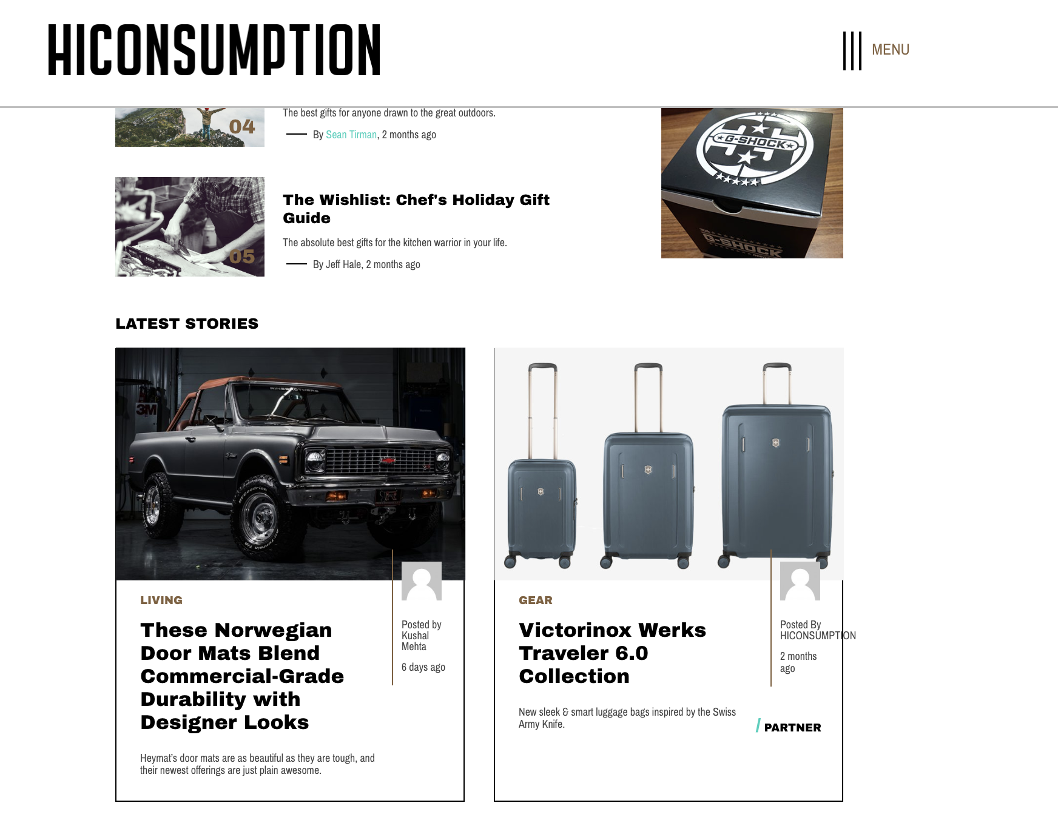

(9 Continued) Reference “Rides” category example attached below. The partner tag should reflect the “homepage”. The Wishlist: Dapper Man's Holiday gift guide should not have a sponsor tag on it.

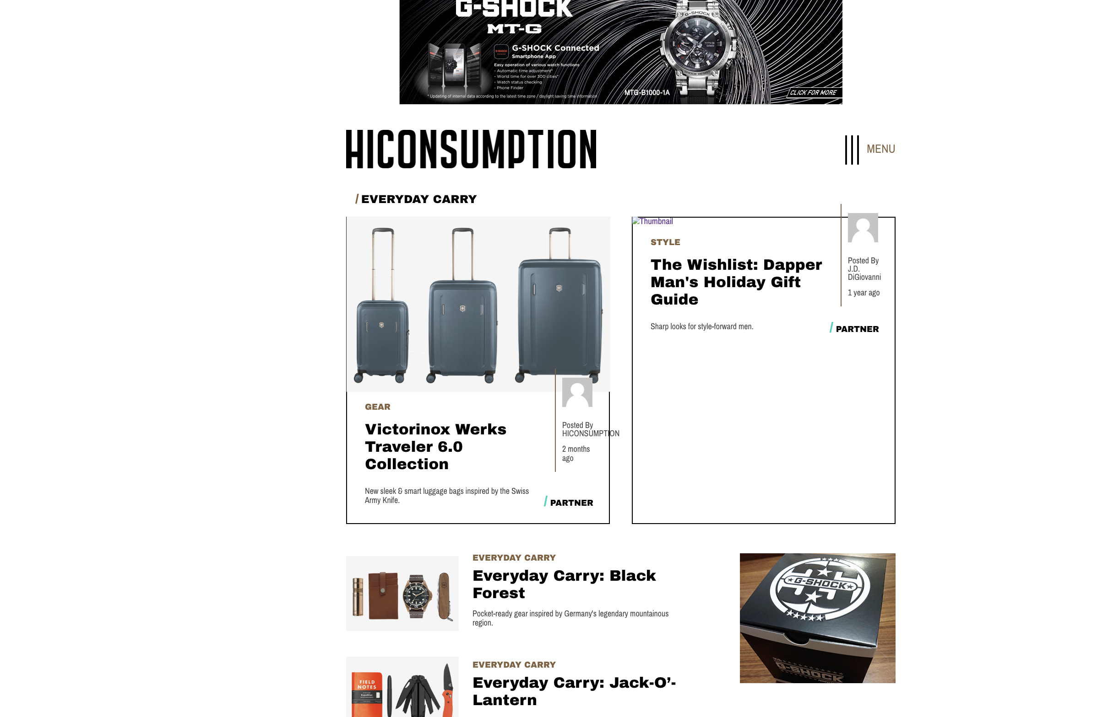

(9 continued) I realize we can add a partner post from that section. I thought it would be a lot cleaner to access it from the same menu as the sponsor content.

-In the admin area, Under Boost Settings > Sponsored Posts we have 2 posts that should be showing up in the designated “Boost Containers.” Unfortunately only 1 of them is showing up.

Client Comment:
Can you add another “Sponsored Posts” menu under “Boost Settings” for the Partner/Boosted post that shows up in the Editor’s Picks section. Let’s call it “Editor’s Picks” and this will allow our Editor the ability to select up to 1 story for the Partner tag.

MD Comment:
Partner post can be added in Editor's pick section from here http://hiconsumption.dev1.in/wp-admin/admin.php?page=brandpoint_settings
Are we discussing about it? please let us know

HiC Answer: yes I know you can the editors pick section from there. It will be more suitable for or staff if we can add another “Sponsored Post” Menu Under “Boost Settings”.

Client Comment:
11. Menu:
Remove the entire “Subscribe To Our Newsletter” section from the left and all of the links/copyright info to the right. We are trying to clean up this page for the user to have easy navigation.

MD Comment:
If you can show some example for better understanding please?

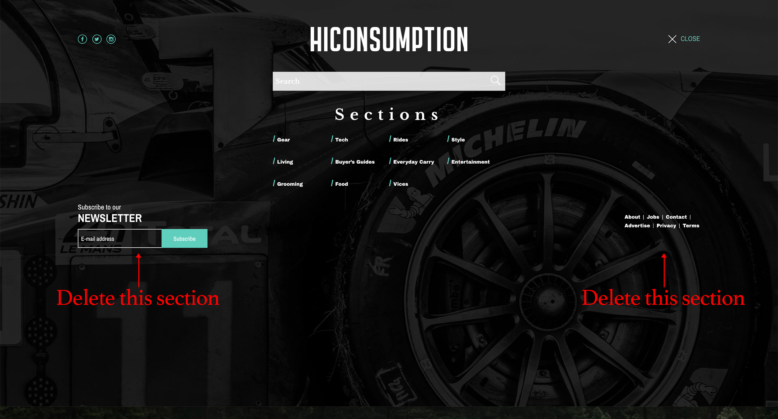

Search Issues

After searching anything on the site, clicking the thumbnail takes you back to the search results, when it should take you to the actual post you clicked.

Point 4:
Client Comment:
Homepage: Please Fix this scaling issue of overlapping words across authors name in “Latest Post” Section.

MD Comment:
Sure, We will break the word whenever it overlap.

Point 9:
Client Comment:
Footer: The “Footer” Breaks down to mobile to soon. Please Reference the 1024 home page psd for correct footer layout. Use that footer layout and scale down. When you hit 550px wide, then switch to the 375 mobile size.

MD Comment:
It is hard to maintain the exact same design as we don't have much space to show the footer. So we have break it to show mobile design.

HiC Answer: Can you propose a solution it does not look good.

Point 18:
Client Comment:
Latest stories: Why do the “latest stories” containers look so good on the 1024 Latest stories psd and looked stretched out when viewed at the 1024 screen size.

MD Comment:
Because in PSD we have fixed 3 lines of title for every post but in website we have many post with long titles. One solution is that we can restrict every title to show only three lines and hide rest of the word. Please let us know your thought.

HiC Answer: Thanks for the Clarification, I think it's all right.

